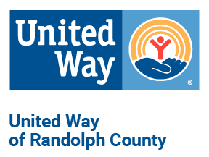
501 W. Rollins St.
Moberly, MO 65270
P: 660-263-6588 | F: 660-263-8818
CAMPAIGN
SPEAKER & MATERIALS REQUEST FORM
Please fill out this form to arrange for a United Way speaker, tour, or other available items. Email Atina Roberts at atina@unitedwayrandolphcounty.org or fax request to 660-263-8818.
Requested by:
Phone number:
Date Needed:
Company/Organization:
Address:
Speaker Request
Dates(s) and time(s) requested:
Desired speaker:
Size of audience:
Length of presentation:
Additional details:

Material Requested | Quantity | Material Requested | Quantity
Pledge Forms |  | Goal Thermometer
Workplace Brochure |  | United Way Poster
Jeans Day Stickers |  | United Way Stickers
Materials will be delivered to your site one week before the date required, unless other arrangements are made.
Speakers can be a representative from any of our agencies, United Way board member, or United Way Executive Director Atina Roberts. Our agencies are: Boy Scouts, Girl Scouts, Christos Center, Community Childcare Learning Center, Food Bank of Central and Northeast Missouri, Moberly Head Start, Magic City Express, 4-H, Safe Passage, The Salvation Army, Senior Americans Multipurpose Center, and Mid-Mo Productivity and Packaging Specialist, and Saint Vincent De Paul.

